**Chapter 6 – MARRIAGE & HONEYMOON**

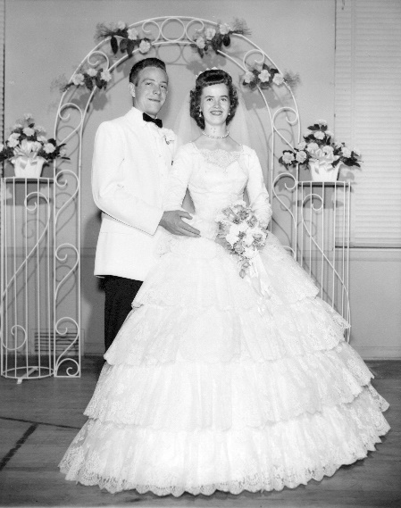We were married in the Salt Lake Temple on the 19th of June 1959, by Elder LaGrand Richards who was an apostle and is a second cousin to my dad. *Elder Richards gave us such a wonderful talk. Some of the council he gave us was to never go to bed upset with each other - to talk it out and then pray together each night before retiring. He said, "you can't pray together if you are mad at each other". He also said to have a weekly date - to keep courting. He told us that once or twice a year we should go on a little vacation by ourselves and leave the children home, if only to the next town and if only for a weekend. That if we can go for a week once in a while, all the better. He said to build a wonderful lasting relationship, we need this time to ourselves. He said to take family vacations also, but that when the children are raised and leave the nest, we want to have built our loving relationship, so our marriage will last. I have been thankful for this advice and we have complied with it and have built a wonderful relationship*. Ken and I are really happy, are best friends and really love and enjoy being together. *He also said that when we get upset with each other, as all couples do, that one of us should go outside and go for a walk to cool off, rather than stay and argue. He said that’s why he is so healthy - that he has gotten lots of exercise and fresh air. We all laughed.*

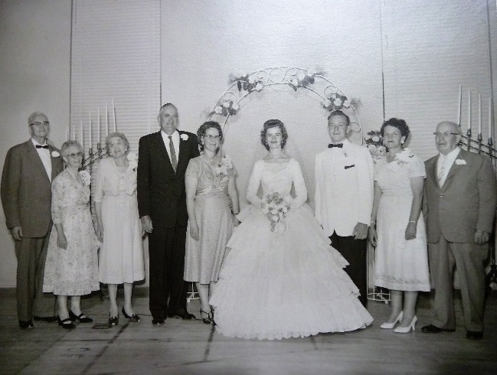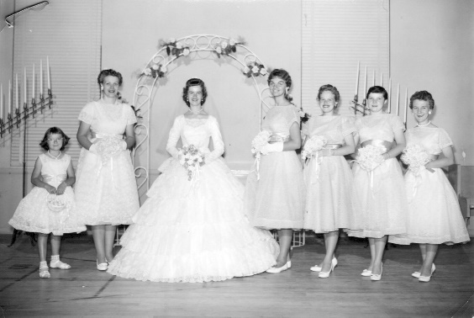**The day was just perfect. We had our reception that night in the Sunset Second Ward Recreational Hall.** Bob was Ken’s best man and Carroll was my maid of honor. My bridesmaids were: My best friend, Pat Bradfield, my cousin, Joann DeGraw and other best friends, Patsy Morris and Eleanor Ewing were my bride’s maids, and my flower girl was my sweet little sister, Georgia. I felt fortunate that three of my four grandparents were also in my line. Grandpa Porter had passed away just before Georgia was born, but Grandma Porter and Grandpa and Grandma Bushnell were still alive. We got so many nice things and so many came that my face hurt from smiling so much. We had a program and a dance after. My grandfather Bushnell sang in our program. He had a beautiful tenor voice. Nada Nicholas, who also has such a beautiful voice and was the wife of our bishop, sang also. Mom’s friend who has a granddaughter who tap danced with a group asked the group to dance in our program. There were several numbers and it was wonderful. Ken and I started the dance and then others followed. A friend of Mom’s who is a caterer made our refreshments, they were delicious.

Ken had to be in training for his job for two weeks - so we couldn't leave on our honeymoon at that time. Instead we went to Provo and stayed in a cute cabin by the Provo River for the weekend. We took a picnic lunch up Provo Canyon on Saturday.

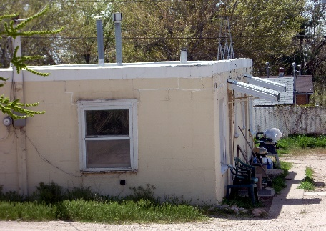**Mom & Dad offered to have us live in one of their duplex apartments at 1747 North Main, Apt 1** at a lower rent ($35.00 a month) so we were excited. The couple who were living there were supposed to be moved out by the time we got married, but they weren't, so we gave them an extra three weeks and we stayed in a motel over in Roy while Ken went to his training for the two weeks. Then we went on our Honeymoon to Yellowstone Park. We had a wonderful time. As we traveled, we ate twirled candy sticks that were left over from our reception. They were really good. We sang songs up and back. I taught Ken the songs I had grown up with and it was fun singing with him. We enjoyed the scenery. We stayed in a small cabin up there. The next morning we woke up really cold. The stove wasn’t putting out hardly any heat. (There wasn't a damper in the stove) Ken was able to fix it, thank goodness. He went out and looked in the big garbage, and found a large coffee can. He took his knife and cut down a ways from the top of the can, every few inches. He then took these cuts and bent them outward. He said we would have to get all the covers we could find and put on our coats because he had to let the fire, in the stove, go completely out. We stayed warm under the covers, and then when the stove was cold, he shoved this can up the smoke stack an lit the firewood in the stove. The stove soon became hot and it put out the heat we needed to keep ward. Wow! I knew then that I had married a smart man that could figure things out to do what needed to be done. It snowed while we were there, so we had snowball fights. One day we heard some commotion over by the large trash cans, so we went over to see what was going on. There were lots of people watching a bear rummaging through the trash. Soon after we got there, the bear turned and started chasing all of us. Ken said I left him in the dust and was racing ahead of all the people. Guess I didn't want to get eaten by a bear. At that time, there were lots of bear in Yellowstone Park. Cars would be off to the side of the road watching and some were even feeding the bears. Since there were accidents with the bears, they were taken to higher ground.

When we got back from our Honeymoon, the couple still had not moved, so we just went and gathered up lots of boxes and went in and helped them move out. When we realized how dirty the apartment was, we were sorry we were going to live there. We had lots of work trying to clean it up. It stunk so bad and we finally moved the refrigerator out and found spoiled meat underneath it. Ken had to take off the top of the stove and soak it in lye in the bathtub for two days before he could get off all the grease and dirt by using a puddy knife. Ken's mom & sister, Aunt Wilma helped us clean as also my Mom & Dad. We had to wash the walls twice before we could paint them. When our apartment was clean, it looked really cute. We were able to purchase a really nice sectional set from a neighbor of Ken’s who wanted a new set. The other furniture was ones Mom had gotten at a second-hand store.

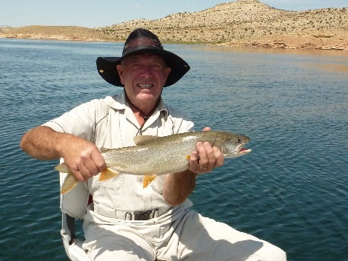

**I found out right away that Ken loved to fish** as one night shortly after we were married and living in our apartment, Ken woke me up suddenly by yelling: **“I’ve caught it, I’ve caught it, it’s a big one, it’s a big one.”** He went fishing as a young boy growing up in Victor, Idaho. He mostly stream fished there, and most of our married life, he would go stream fishing. I would go with him sometimes and take a book and camp chair and read while he fished. He went fishing with his brothers, and with neighbors and friend. We camped a lot, and many were camping/fishing trips, but they were fun and we both loved to eat the fish. After we returned from our Philippine Mission in 2005, we went fishing with my cousin, Randy Porter, and his wife, Judy. They had a boat and we had so much fun, that on the way home, I suggested that he might want to buy a boat. He loved that suggestion and it didn’t take him long to find a nice fishing boat. He has loved it, I have too. We have caught many fish in that boat. We have taken family, mostly Sandi and Nick and grandsons. We have taken friends and extended family, Ken has taken my cousin, Randy, many times with him. Sometimes they went in Randy’s boat, but Ken always has to do all the work as Randy is blind. Randy helps pay the expenses. A friend, Ron Graf, loves to go with Ken also.